**Shelters building, generation of Energy and getting Water on the Moon and Mars.**

Victoria Levkine (email [mst@mathship.com](mailto:mst@mathship.com))

Guennadi Levkine (email [hlevkin@gmail.com](mailto:hlevkin@gmail.com))

**Mathship Technologies**

Gibsons, BC, Canada

**Abstract.** We add it later.

**Key words**: solar system; colonization; Moon living; Mars living

**1. Introduction: problem and terminology.**

Now it is the main problem for Human civilization.

This article discusses possible solutions to this problem.

Duration of human’s stay on the Moon and Mars:

* Half of a day without sleep (American on the Moon)
* With sleeping one week
* One month
* Half year and mores
* All remaining life without returning to Earth

Here we will discuss the last case.

**2. Three most important things for living on the Moon and Mars.**

**Energy** is base of all:

* Chemical for rocket engine
* Solar batteries
* Nuclear reactors

**Water** is:

* the oxygen for humans
* gas for motors on the Moon and Mars

**Shelter** is the most important for human living:

* Protection against Solar Radiation
* Humans are living as in the Earth’s House if they will be there half year and more.
* Source of Food and Processors of Human’s waste (carbon dioxide, urine, feces): greenhouses
* Relaxation

**4. Sources of water on the Moon and Mars.**

**5. Construction of energy systems on the Moon and Mars.**

**6. Steps to build shelter.**

**7.**

**8.**

**9.**

**10. Conclusions.**

Make them yourself if you plan to live on the Moon or Mars.

**11. Acknowledgments.**

We are very thankful to researchers who ...

**Literature**

1. How to build a Moon base <https://www.nature.com/articles/d41586-018-07107-4>

A new home on Mars: NASA Langley’s Icy Concept for Living

1. on the Red Planet <https://www.nasa.gov/feature/langley/a-new-home-on-mars-nasa-langley-s-icy-concept-for-living-on-the-red-planet>
2. . . .

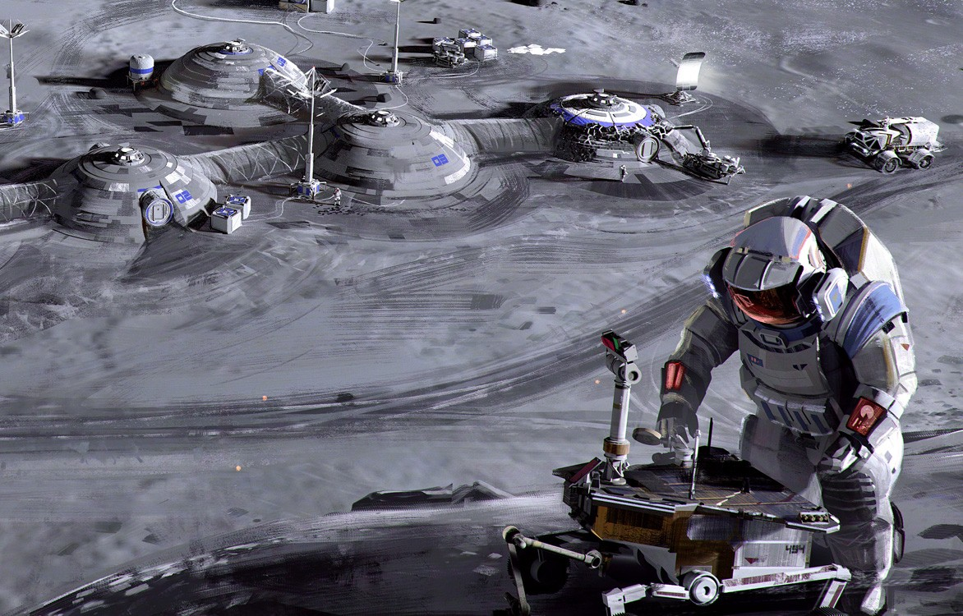

Picture 1. Moon Base

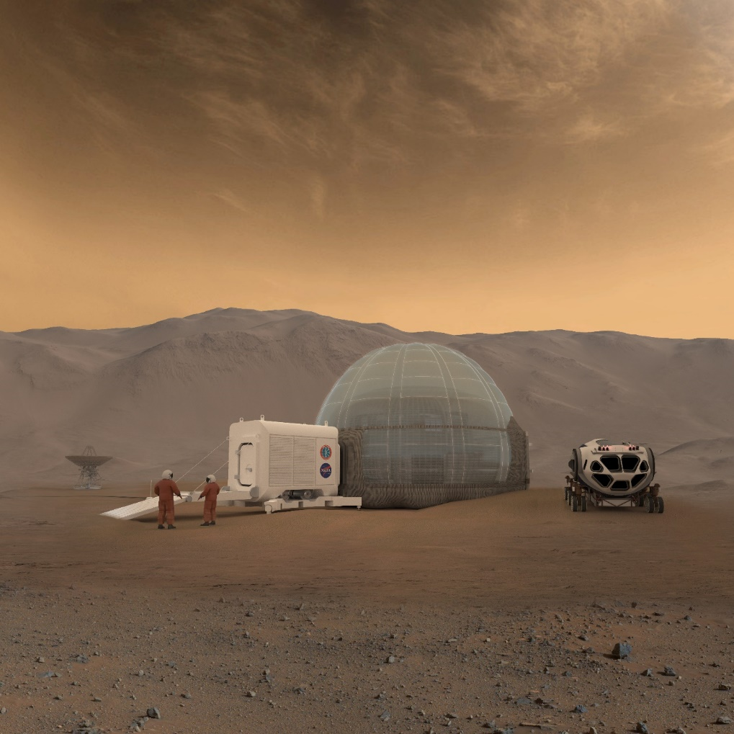

Picture 2. Mars Base