**Moon, Mars, and Outer Space Greenhouses**

Victoria Levkine (email [mst@mathship.com](mailto:mst@mathship.com))

Guennadi Levkine (email [hlevkin@gmail.com](mailto:hlevkin@gmail.com))

Mathship Technologies

Gibsons, BC, Canada

**Abstract.** We add it later.

**Key words**: solar system; colonization; Moon living; Mars living; living in outer space; greenhouse; mars soil; moon soil

**1. Introduction: problem and terminology.**

living in space impossible from greenhouses .

This article discusses how to build greenhouses on the Moon, Mars, and in outer space.

**2. Requirements to Moon, Mars and outer space greenhouses .**

* Safety for humans in Greenhouse
* Reliability
* Long time of work
* Productivity
* Construction Simplicity
* Easy repairing

**3. Sources of Energy, Water and Soil.**

**Energy Sources:**

* Solar water hitting systems
* Solar batteries
* Nuclear reactors

**Solar water hitting systems**

ACTIVE

Direct circulation systems: Pumps circulate water through the collectors and into the home.

PASSIVE

Integral collector-storage passive systems: Made of a storage tank, solar collection tank, and the pipes that run between them, these systems require cold water to be pumped into the solar collector in batches.

**Solar batteries**

**Nuclear reactors**

**Sources of Water:**

* On Mars
* On the Moon
* In outer space – asteroids and orbital stations

**On Mars**

**On the Moon**

**In outer space** – asteroids and orbital stations

**Soil:**

* On the Moon
* On Mars
* In Outer Space– asteroids and orbital stations

**On the Moon**

**On Mars**

**In Outer Space**

Minimal soil, using a lot of water

**4. Specifical Architecture of Greenhouses.**

**5. Materials for Construction**

Most of materials must be in please of greenhouse building

**6. Steps to build Greenhouses.**

* finding the right place
* prepare raw materials.
* Prepare glues.
* Prepare glass in for infrared and visible electromagnetic radiation only
* Easy transportation to the place of greenhouse building

**7.**

**8. Specific of greenhouse building on asteroid**

**9. Greenhouse building on Jupiter and Saturn satellites**

**10. Conclusions.**

Make them yourself if you plan to live on the Moon or Mars.

**11. Acknowledgments.**

We are very thankful to researchers who ...

**Literature**

1. Bob Granath “Lunar, Martian Greenhouses Designed to Mimic Those on Earth”, Kennedy Space Center FL (SPX) Apr 25, 2017

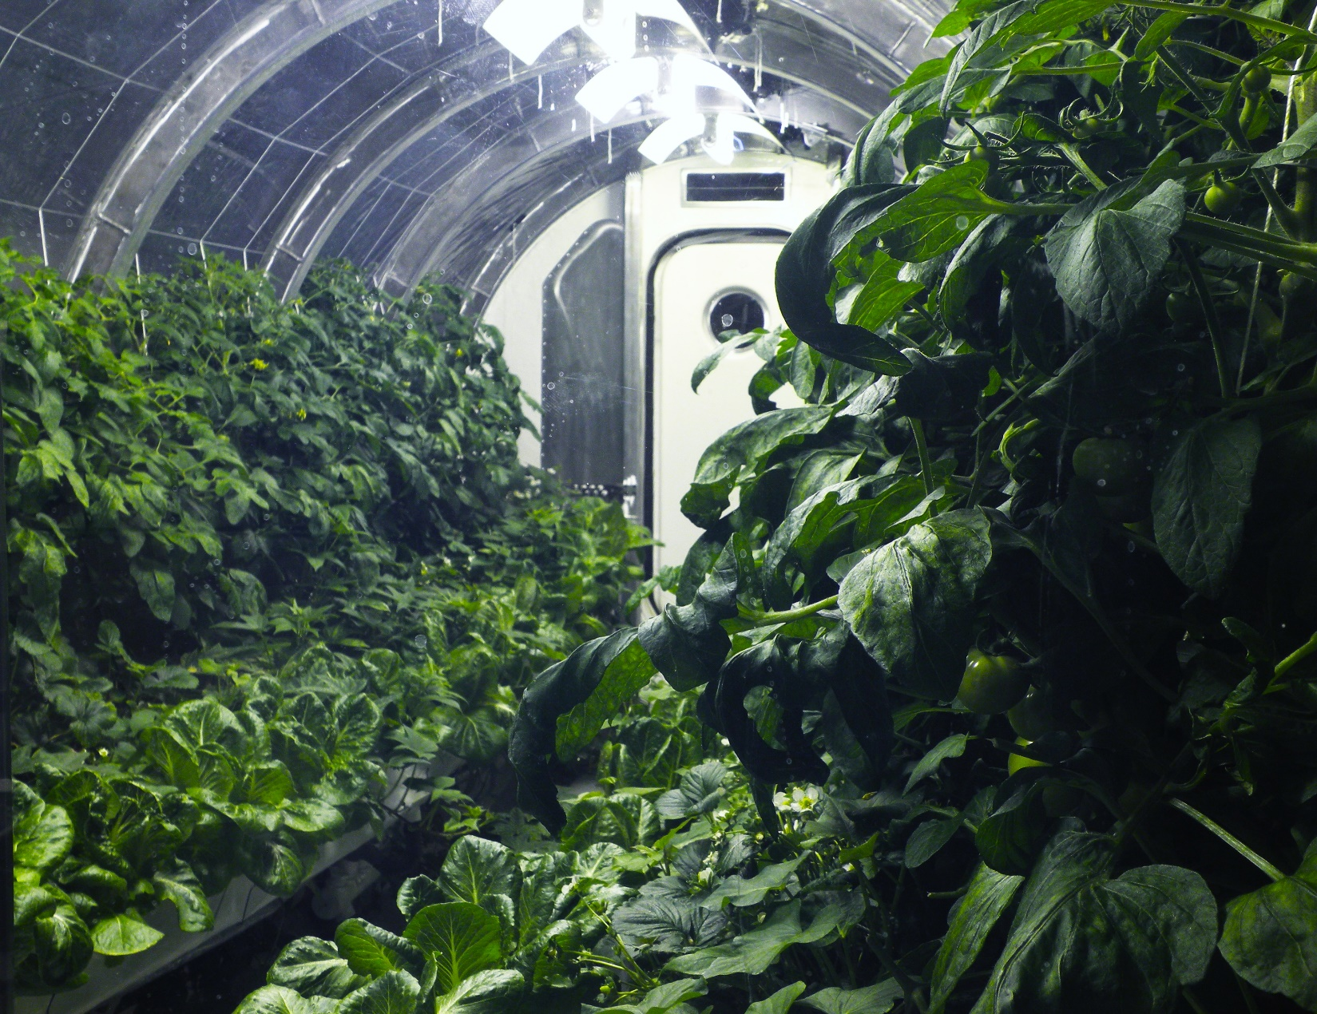

Picture 1. The Moon. From [1]



Picture 2. Mars

Picture 3. Outer Space