Solar Cycles Start Time Prediction using
Jupiter and Saturn positions
Guennadi Levkine (email hlevkin@gmail.com)
Mathship Technologies
Gibsons, BC, Canada
Abstract. The article deals with the problem of predicting solar activity. Solar flares, coronal mass ejections, high-speed solar wind, and solar energetic particles are all forms of solar activity. The solution to this problem is important for many areas of technical activity, agriculture, and space research. Current prediction methods are based on the study of solar tests and their forecasting. The proposed method (SSM) is based on the definition of Solar Activity as the magnitude of the Solar Magnetic Field (SMF). It is very accurate and based on the use of the position of Jupiter and Saturn. The proof of its correctness is the calculation of the times of the beginning of solar cycles and comparing them with the measured times.
Key words: solar activity; solar magnetic field; SMF forecast; SMF dynamo model; solar circle; SSM;
- History
Wolf's discovery and the periodicity of the appearance of sunspots. Look at [1].
А.Chizhevsky was the first to carry out quantitative measurements of the influence of the Sun on the Earth, in particular on the number of insect pests. To estimate solar activity, he used the number of sunspots (Wolf index).
He also pointed out that intense wars often start when the sunspot count is low.

2. Terminology and Importance of SA forecast
Solar activity determines a lot on Earth: the discovery of Alexander Chizhevsky.
The problem of predicting Solar Activity is extremely important for the inhabitants of the Earth.
Now this has become especially important thanks to Astronautics. In particular, the calculation of the start time of the next Solar Cycle.
Article [2] gives an overview of the current state of this (our successes and failures).
In our article, we have redefined the SA level. It is measured by the SMF value. We describe a method for predicting SA.

3. SA measurements
Index definition in Pesnell Article.
Wolf numbers measure the number of sunspots and groups of sunspots present on the surface of the Sun. They are estimate SA.
Wolf numbers are now used to predict solar activity. But this method is very imprecise for two reasons:
- Wolf numbers inaccurately determine the level of solar activity
- it is easy to accurately determine the Wolf numbers themselves
Currently scientists are looking for the best definition of Solar Activity Using Wolf Numbers. It des
Literature [2]

4. Solar Dynamo Model (SDM) for description of SMF generation
SDM assumes that SMF is created by plasma flows (electric currents) in the Convective Zone.
Literature [3], [4], [5], [6], [7], [8]
Magnetohydrodynamic equations (Babcock)
Figure 1. Solar Dynamo Model (SDM).
The interior plasma flow: the right-hand cross-section is the toroidal flow; the left-hand cross-section represents the meridional (poloidal) flow.

5. Model (SSM) for description of SMF generation.
It is based on guesswork. that the SMF is created by the plasma flow in the Sun's Core.
The stream is a rotating plasma around the solar axis in planes parallel to the plane of the solar equator.
Figure 2.
[9]
6. Sun Movement around Center of mass of Solar System.
Planet movement defines Sun movement. This is the result of the gravitational interaction between the Planets and the Sun. Not only planets move in orbits around the Sun, but also the Sun relative to the common center of mass. Only the displacement of the Sun is much smaller than the size of the orbits of the planets.
Articles [10], [11], [12] describes the Sun’s Orbital Motion under influence of planets.
Figure 2. The Path of the Center of Mass of the Solar System
Points on Sun trajectory where acceleration is 0 and maximal, times of when is happened.
7. Core plasma stream generation.
As a result of the movement of the Sun, the movement of plasma arises in the Core.
How it can be happened?

8. SMF is generating by rotating core plasma.
Biot - Savart equation
Rotating plasma works like an electric current in solenoid.
Aс a result it creates magnetic field (SMF)
Logics:
- The sun causes the movement of planets in orbits
- the movement of the planets causes the movement of the sun
- The movement of the Sun leads to a circular motion of the plasma in its Core
- the movement of the Nucleus plasma creates an SMF
Look at Figure 3, 4.

9. Jupiter and Saturn movement defines SMF value.
It was found that only Jupiter and Saturn determine the value of SMF.
It is only thanks to Jupiter and Saturn that the rotation of the plasma occurs in the Sun’s Core.
We derived the formula that allows us to calculate the value of the SMF using the tables [13] from where the coordinates of Jupiter and Saturn were taken.
10. Solar Cycle (SC) Definition. SC Transition Times (SCTTs).

Solar flares, coronal mass ejections, high-speed solar wind, and solar energetic particles are all forms of solar activity. All solar activity is driven by the solar magnetic field.
The solar cycle is the time from one moment in time when the SMF is zero until the next such moment. These moments are called as Transition Times.
The greatest impact of the Sun on the Earth occurs when the SMF level is close to zero (at these moments number of protons leaving the Sun is maximal.)
That is why Transition Times are very important.
Files [14], [15] [16], give transition times from 2700 BC to 2150 AD.
11. Solar History. Timelines and SCTTs juxtification.
SCTT = SC Transition time
Correlation of Timeline events and SCTTs:
Example: select events – birth dates of famous scientists and build histogram of birth times distances to Transition Times.
Look at figure 5, where is that histogram. Main part of birth dates are close to Transition Years,
270 from 374 scientists (72%) are burn in range +/- 2.5 years around Transition years.
If there is no dependence, it will be 21% only.
Other examples of Timeline Events:
- Timeline of scientific thought: https://en.wikipedia.org/wiki/Timeline_of_scientific_thought
- Technology timeline: https://www.explainthatstuff.com/timeline.html
- Timeline of scientific discoveries: https://en.wikipedia.org/wiki/Timeline_of_scientific_discoveries
- List of wars before 1000 AD: https://en.wikipedia.org/wiki/List_of_wars:_before_1000
- List of wars: 1000–1499: https://en.wikipedia.org/wiki/List_of_wars:_1000–1499
- List of wars: 1500–1799: https://en.wikipedia.org/wiki/List_of_wars:_1500–1799
- List of wars: 1800–1899: https://en.wikipedia.org/wiki/List_of_wars:_1800–1899
- Timeline of pandemics: https://www.history.com/topics/middle-ages/pandemics-timeline
Processing of these timelines gives similar results, as in the case birth dates of famous scientist’s timeline.
Carrington Event:
This case is interesting because it happened in the middle of Solar Circle, between two Transition Times.
An example of the fact that SMF may not keep protons on the surface of the Sun – Carrington Event.
Just a few months before the solar maximum on 1860.1, during the 10th solar cycle many sunspots appeared on the Sun from August 28 to September 2, 1859
12. SC Transition Time Prediction testing.
The best way of fast proof of our prediction of SC Transition Times is direct SMF measurement.
Our prediction works for SC22-SC25.
Table 1. SC Transition Times
Solar Cycle | Transition time
SC 21 | 1981, Jan 01
SC 22 | 1990, Jul 14
SC 23 | 2000, May 28
SC 24 | 2011, Mar 29
SC 25 | 2020, Dec 22
SC 26 | 2030, Nov 30
SC 27 | 2039, Apr 02
SC 28 | 2047, May 02
SC 29 | 2057, Jan 10
SC 30 | 2063, Oct 25
SC 31 | 2070, Oct 25
SC 32 | 2077, Apr 17
SC 33 | 2087, Nov 10
SC 34 | 2096, Jul 04
SC 35 | 2100, Jan 14

13. Conclusions.
That method of SMF prediction is properly working and gives humans and governments information about dangerous events, climate, good and bad crops and so on.
14. Acknowledgments.
We are very thankful to researchers who …
Appendix A. Sun Trajectory calculation (Matlab program).
k=1;
N = 1000; # number of steps
T = k * 0.9300e+08; # time interval-Saturn period in secs
step = 1e5;
# Parameters:
g = 6.674e-11; # gamma
# Masses
m1 = 18.98e+26; # Jupiter
m2 = 05.683e26; # Saturn
M = 1.989e+30; # Sun
# Orbits
a1 = 0.81662e+12; b1 = 0.74052e+12 ; # Jupiter
a2 = 1.5145e+12; b2 = 1.3526e+12; #0.9e12 Saturn
# trajectories
jupiterX = zeros(1, N);
jupiterY = zeros(1, N);
saturnX = zeros(1, N);
saturnY = zeros(1, N);
sunX = zeros(1, N+1);
sunY = zeros(1, N+1);
xx = zeros(1, N+1);
yy = zeros(1, N+1);
# initial values of position and velocity
sunX(1) = +200000;
sunY(1) = -700000;
sunVx(1) = 0;
sunVy(1) = 0;
for i=1:(N+1)
#disp('----------------------------');
printf("i= %d ", i);
jupiterX(i) = a1*cos((2*pi/N)*i);
jupiterY(i) = b1*sin((2*pi/N)*i);
saturnX(i) = a2*cos((2*pi/N)*i);
saturnY(i) = b2*sin((2*pi/N)*i);
#printf("%f %f %f %f\n", jupiterX(i), jupiterY(i), saturnX(i), saturnY(i));
r1 = jupiterX(i)^2 + jupiterY(i)^2;
r1 = r1^1.5;
r2 = saturnX(i) ^2 + saturnY(i) ^2;
r2 = r2^1.5;
if i==1
sunAx(i) = g * M * (m1*jupiterX(i)/r1 + m2*saturnX(i)/r2);
sunAy(i) = g * M * (m1*jupiterY(i)/r1 + m2*saturnY(i)/r2);
else
sunX(i)= sunX(i-1)+sunVx(i-1)*step+sunAx(i-1)*step*step/2;
sunY(i)= sunY(i-1)+sunVy(i-1)*step+sunAy(i-1)*step*step/2;

sunAx(i) = g * M * (m1*jupiterX(i)/r1 + m2*saturnX(i)/r2 );
sunAy(i) = g * M * (m1*jupiterY(i)/r1 + m2*saturnY(i)/r2 );
sunVx(i) = sunVx(i-1)+ ( sunAx(i-1) + sunAx(i) )*step/2;
sunVy(i) = sunVy(i-1)+ ( sunAy(i-1) + sunAy(i) )*step/2;
endif
xx(i)=sunX(i)/1e33;
yy(i)=sunY(i)/1e33;
printf("%f %f\n",xx(i),yy(i));
end
#--------------------------------------------------------------------
# trajectories plot
figure;
plot(jupiterX , jupiterY, 'linewidth', 2, "linestyle", ':', 'color', 'g')
hold on
plot(saturnX , saturnY, 'linewidth', 2, "linestyle", ':', 'color', 'b')
hold off
figure;
for i=1:(N+1)
# sunX(i)=sunX(i)/1e33;
# sunY(i)=sunY(i)/1e33;
end
xx=sunX/1e33;
yy=sunY/1e33;
plot(xx(2:N) , yy(2:N), 'linewidth', 2, "linestyle", ':', 'color', 'r')

Appendix B. Histogram of Birth years of famous scientists comparing with SC Transition Times (Matlab program).
fn = 'tteData.txt'; # Data filename;
N = 374; # number of scientists
# intervals where they were born
scleft = zeros (1, N); # Left SC
scright = zeros (1, N); # Right SC
# times when they were born
birthdays = zeros (1, N);
#--------------------------------------------------------------------
# Number of bins in histogram
B = 12;
# histogram array
hh = zeros (B, 1);
#--------------------------------------------------------------------
# read file with scleft, scright, birthdays
fid=fopen(fn);
matr = fscanf(fid,'%g %g %g',[3 N]);
matr = matr';
for i=1:N
res=matr(i,:);
dl = int32( (res(3)-res(1)) ) +1;
dr = int32( (res(2)-res(3)) );
if dl<=dr
d=dl;
else
d=dr;
endif
hh(d)++;
end
#--------------------------------------------------------------------
# histogram print and plot
Disp (hh');
xx= 1 : 1 : B;
plot (xx, hh, 's', 'linewidth',4, "linestyle", ':', 'color', 'r');
fclose(fid);

Literature.
- Discovery of the Sunspot Cycle Link: https://pwg.gsfc.nasa.gov/Education/whschwab.html
- W. Dean Pesnell, “Solar Cycle Predictions (Invited Review)”, Solar Physics volume 281, pages 507–532 (2012)
- Babcock, H. W. “The Topology of the Sun's Magnetic Field and the 22-YEAR Cycle. “, Astrophysical Journal, vol. 133, p.572
- Leighton, Robert B. "A Magneto-Kinematic Model of the Solar Cycle". The Astrophysical Journal. 156: 1969
- Charbonneau, Paul “Solar Dynamo Theory”, Annual Review of Astronomy and Astrophysics, vol. 52, p.251-290
- Mark S. Miesch, Review article “The solar dynamo” Philosophical Transactions of the Royal Society, Mathematical, Physical and Engineering Sciences
- Dean Pesnell “The Future of Solar Cycle Forecasts”
- Mausumi Dikpatu “Solar Dynamo Models”
- http://mathship.com/080SMFandSSM.html
- Jose Paul D., “The Sun’s Orbital Motion”, Popular Astronomy, Vol. 44, p.542, 1936
- Guerra1, Carvalho, “Orbital motions of astronomical bodies and their Centre of Mass from different reference frames: a conceptual step between the Geocentric and Heliocentric models”, Submitted to Phys. Educ., May 2016
- Lubomir Vlcek “Orbit radius and speed of the Sun around the center of gravity of the Solar System”, http://citeseerx.ist.psu.edu/viewdoc/download?doi=10.1.1.456.1933&rep=rep1&type=pdf
- Swiss Ephemeris for Users, https://www.astro.com/swisseph/swepha_e.htm
- Transition SC times for centuries XXX BC to XXI BC, http://mathship.com/200/5000_2002_BC.html
- Transition SC times for centuries XX BC to I BC, http://mathship.com/200/2000_3_BC.html
- Transition SC times for centuries I AD to XXII AD, http://mathship.com/200/1_2251_AD.html
- R. Carrington MNRAS vol. 20, Issue 1, November 1859, Pages 13–15
- “Carrington Event” article in Wikipedia, https://en.wikipedia.org/wiki/Carrington_Event#:~:text=The%20Carrington%20Event%20was%20a,largest%20geomagnetic%20storm%20on%20record
- Scientists Timeline Index https://www.timelineindex.com/content/select/820/1023,820

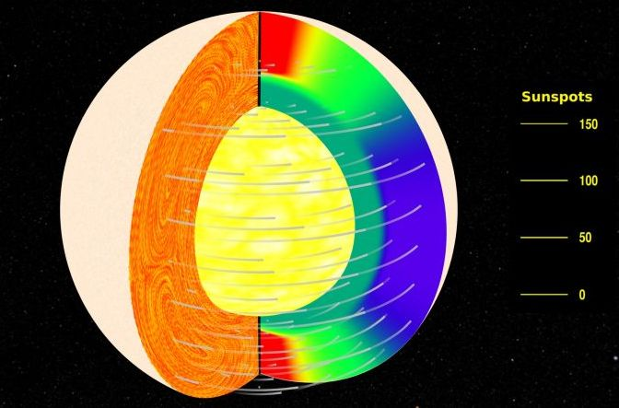

Figure 1. Solar Dynamo Model (SDM).

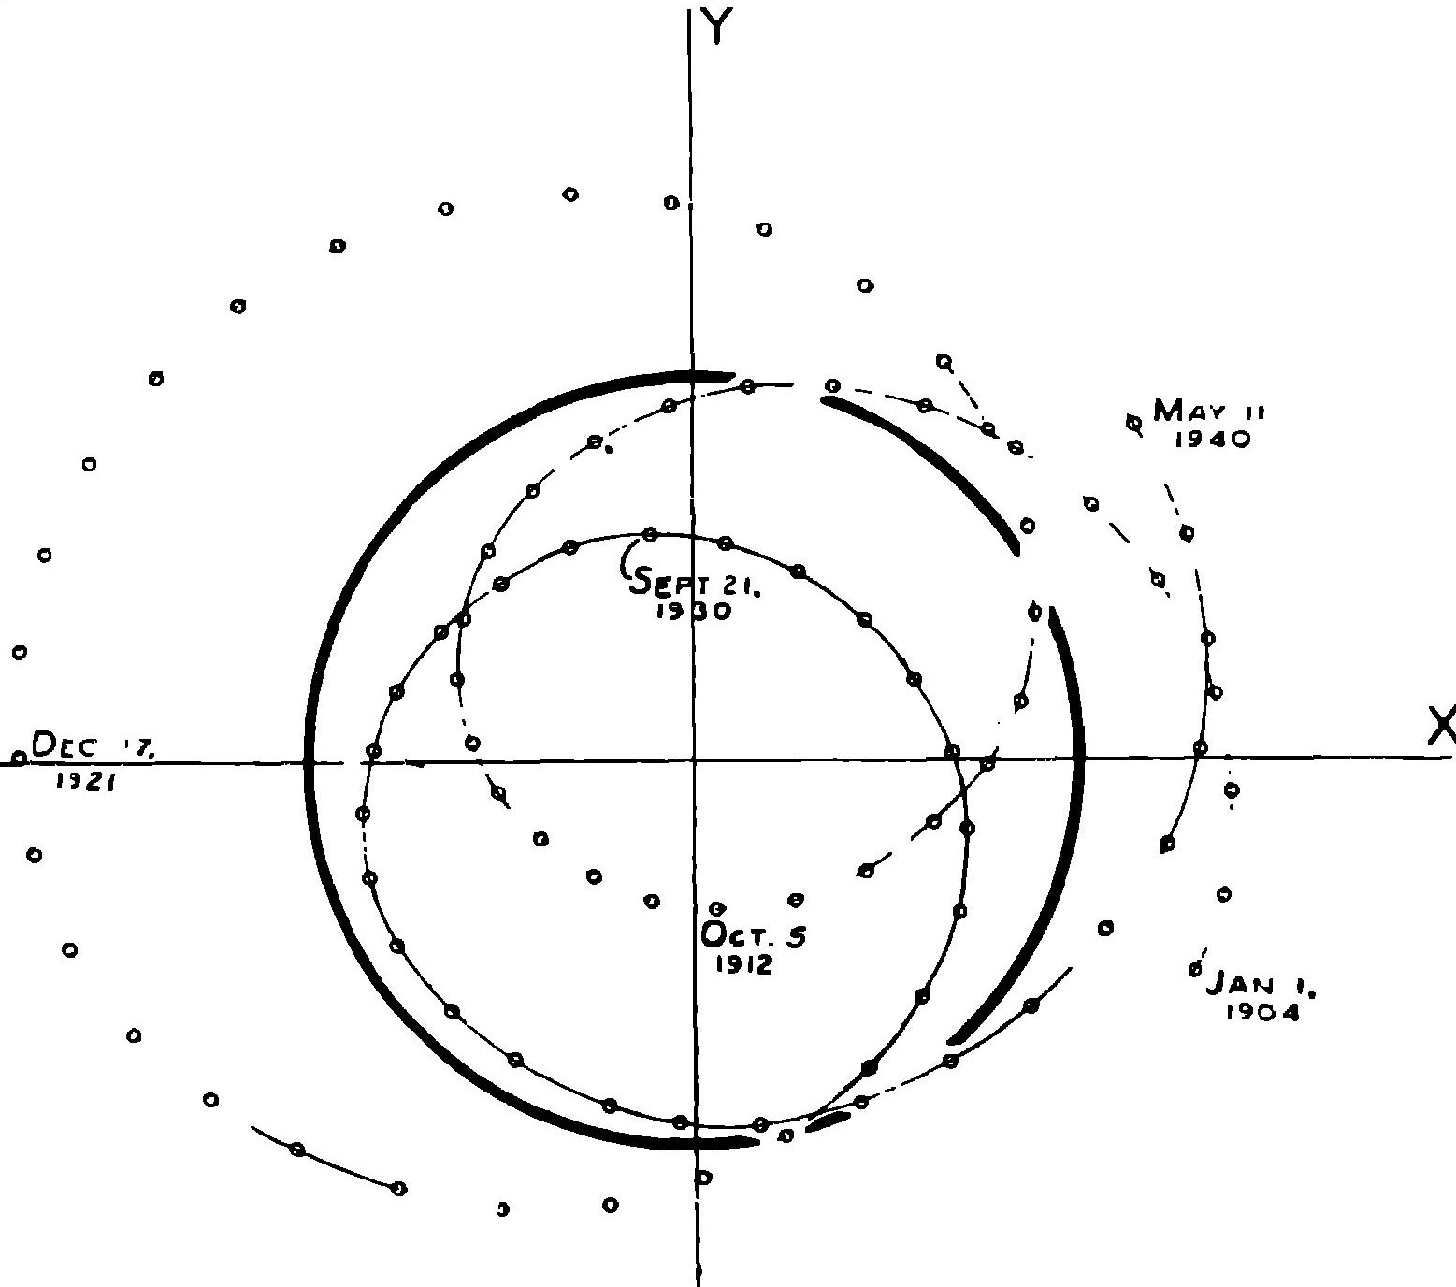

Figure 2. The Path of the Center of Mass of the Solar System referred to the Sun (from [7]).

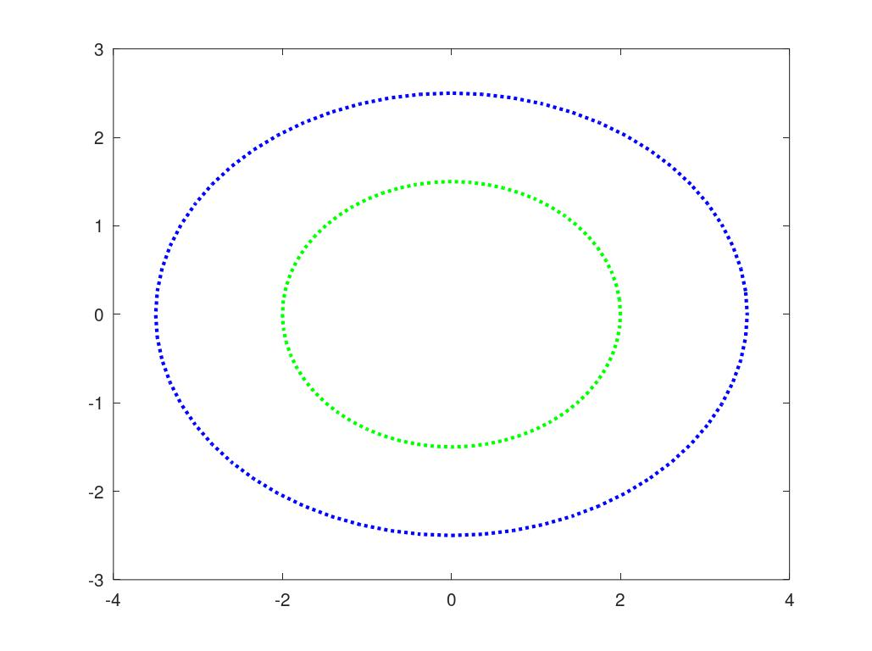

Figure 3.

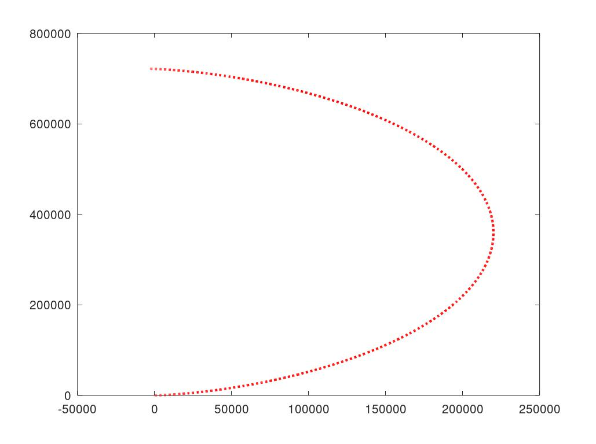
Figure 4.
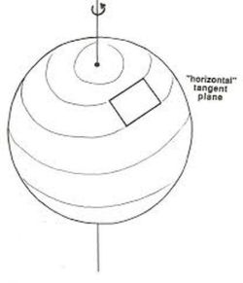
Figure 5. Solar Sensitive Model (SSM) – Core rotation.

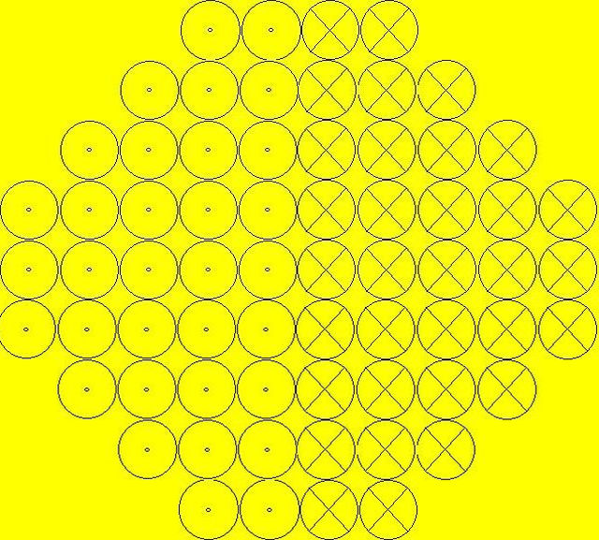

Figure 6. Splitting the core of the Sun into tori with plasma flows in them.

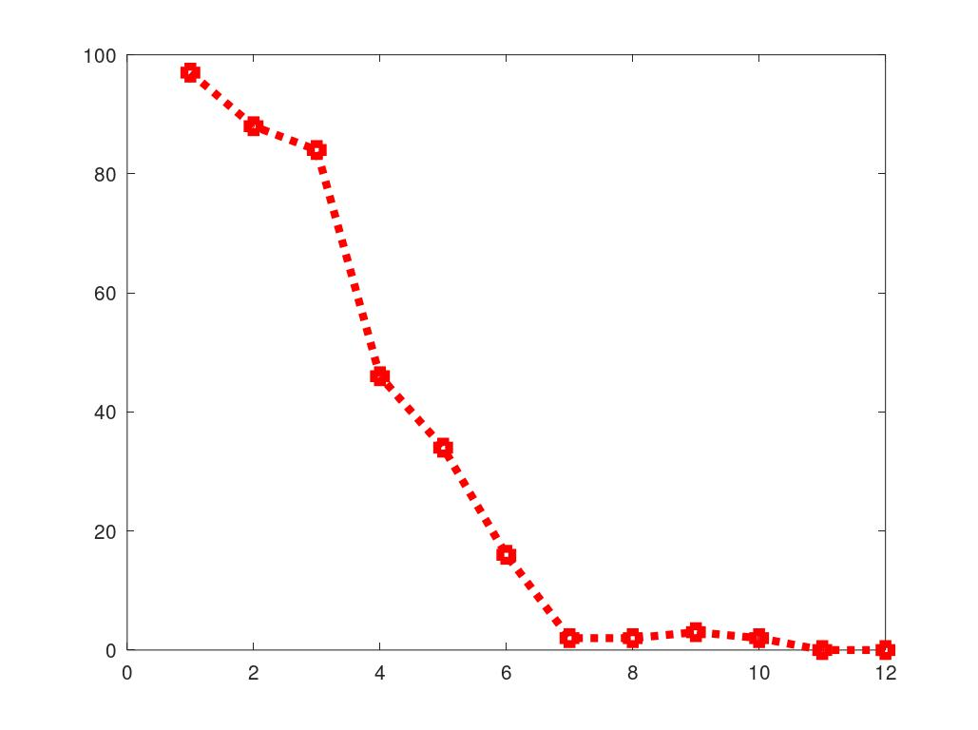
Figure 7. Difference histogram: SC start - Scientist's Year of Birth

