**Larch Growing and Solar Activity.**

**Sergei Kucherov, PhD**

Email [skucherov@mail.ru](mailto:skucherov@mail.ru)

Botanical Garden institute

Ufa Scientific Center of Russian Academy of Sciences,

450080 Ufa, Mendeleev Street, 195, corpus 3

**Guennadi Levkine**

Email [hlevkin@gmail.com](mailto:hlevkin@gmail.com)

R&D Chief Technical Officer ( CTO )

Mathship Technologies,

PO Box 1791**,** Gibsons, BC, Canada

**Abstract.** This article describes the relationship between Solar Activity and speed of Larch growing

**Key words**: Chizhevsky; Solar Activity; larch; wood growing;

**1. Introduction: problem and terminology**

To find relationship between Solar Activity and speed of Larch growing

It proves that there is such relationship.

**2. Chizhevsky Ideas review**

**3. Larch growing data (biology)**

R(t)

1631 – 2005 (16 years in a row):

1631 - 0.55 0.64 0.88 0.91 1.90 1.88 1.22 0.44 0.85 0.97 0.76 0.58 1.12 1.56 1.82 1.34

1647 - 0.77 0.73 1.04 0.80 1.19 1.36 1.13 1.03 1.34 0.82 0.87 1.30 0.82 1.37 0.82 0.98

1663 - 0.43 0.67 0.93 1.26 1.69 1.45 0.88 1.22 1.11 1.14 0.43 0.63 0.66 0.90 1.02 1.44

1679 - 0.86 1.22 0.64 0.78 1.06 0.50 0.55 1.07 1.44 0.61 1.20 1.25 1.03 0.78 0.83 1.01

1695 - 1.43 0.60 1.01 1.43 1.14 1.38 1.78 1.18 1.09 0.44 0.45 0.35 1.09 1.06 0.45 1.11

1711 - 1.59 1.50 0.61 0.73 0.61 1.28 1.29 1.56 1.88 0.73 1.44 1.55 0.50 0.99 0.76 0.67

1727 - 0.48 0.92 1.01 0.79 0.80 0.65 1.12 1.08 1.39 0.75 1.59 1.16 1.80 1.36 0.39 0.87

1743 - 0.50 0.26 0.37 0.77 0.78 1.48 1.92 0.87 0.85 1.41 0.94 1.16 0.71 1.18 0.92 0.47

1759 - 0.53 0.83 1.06 0.63 1.39 1.24 0.49 0.95 0.65 0.73 0.34 0.88 1.04 1.64 1.37 1.44

1775 - 1.34 1.39 1.26 0.93 1.38 1.71 0.57 1.80 0.92 0.80 0.69 0.66 1.23 0.43 1.07 0.75

1791 - 1.12 1.10 1.06 1.43 0.42 1.03 1.24 1.46 0.51 0.72 1.18 1.31 1.51 1.60 0.84 0.75

1807 - 0.81 0.59 1.00 0.74 1.06 0.77 1.00 0.68 0.58 1.06 1.18 1.57 0.59 0.74 0.29 1.40

1823 - 0.74 1.49 0.83 0.61 1.12 0.86 1.16 1.30 1.13 0.48 0.36 0.94 1.30 1.30 1.80 1.67

1839 - 0.87 0.85 0.43 0.84 0.63 0.96 1.33 1.33 1.35 0.41 0.60 0.80 1.16 1.24 1.62 0.95

1855 - 1.78 1.36 1.36 1.43 1.12 0.56 1.01 0.74 0.87 0.39 0.50 0.78 1.13 1.44 0.63 1.14

1871 - 0.93 0.89 0.50 1.25 1.70 0.90 1.08 0.97 0.52 1.04 1.84 1.76 1.03 1.25 0.83 1.90

1887 - 1.63 0.43 0.90 0.56 0.20 0.86 0.81 1.79 1.19 1.59 0.93 0.71 1.03 0.59 1.12 0.93

1903 - 0.70 0.88 1.55 0.52 0.79 0.66 0.75 0.81 0.44 0.65 1.19 0.71 1.07 1.36 0.93 1.11

1919 - 1.47 0.58 0.29 1.02 0.55 0.83 0.68 1.88 1.12 1.02 0.77 1.62 0.78 0.69 0.46 1.29

1935 - 2.37 0.65 0.89 1.10 0.44 1.15 1.23 1.19 0.75 1.80 1.18 1.77 2.65 0.78 1.08 1.42

1951 - 0.91 0.37 0.68 0.80 0.23 0.78 0.40 0.36 0.73 1.46 0.48 1.49 1.20 1.44 0.74 0.96

1967 - 1.24 1.48 1.68 1.17 1.92 0.75 0.74 1.05 0.32 0.49 0.43 0.92 0.97 0.89 0.80 0.45

1983 - 1.61 0.62 1.22 1.37 0.88 0.78 0.62 1.22 0.39 0.68 1.99 2.24 0.79 0.55 0.95 0.40

1999 - 1.3 2.23 0.76 0.99 1.21 0.96 0.51

Histogram of R(t): Picture

**4. Graph of Larch growing data**

Picture 2

Autocorrelation graph and its analysis -Picture 3



R’(t)

Its histogram

Graph of R’(t)

Autocorrelation function

**5. Solar activity Description**

- The core of the Sun rotates

- Rotation of the Core creates SMF = Solar Magnetic Field or SMF

- The rotation of the Core slows down and speeds up

- Jupiter and Saturn control the rotation of the Core!

- When the rotation stops, the output of protons into outer space in the plane of the ecliptic increases sharply

- Sunspots appear at the maximum rotation speed, while the SMF is maximum and the number of emitted protons decreases sharply

- The time between two stops is called the Solar Cycle (SC)

- Last stop was December 22, 2020. We have now entered SC 25.

- The next stop will be on November 30, 2030, the start of Cycle 26

**6. SMF data**

F(t) – Solar Magnetic Field as unction of time

1631 – 2005

For every year two points 2 January and 2 July

Histogram of F(t)

Graph -Picture 3,

Autocorrelation function – Picture 4

Reference to data in Mathship.com.

**7. First and second derivatives of SMF (from Mathship.com)**



Calculate first derivative F’(t)

Histogram

Its graph Picture 5, its autocorrelation function picture 6



Calculate second derivative F’’(t)

Its graph Picture 7, its autocorrelation function picture 8

**8. Solar Activity (x) – larch growing**

Graph F(t) - R(t) Picture 9

Histogram

Correlation Matrix [ R(t); F(t); F’(t); F’’(t)]

Regression Analysis:

R(t) = a + b*F(t) + c*F’(t) + d*F’’(t)

**9. Two-way ANOVA**

**10. Ideas for future.**

R(t) / F(t)

R(t) / F’(t)

R’(t) / F(t)

R’(t) / F’(t)

**11. Conclusions.**

We gave proof of dependency of

**12. Acknowledgments.**

We are very thankful to Viktoria Levkine who discussed with us subject of the article and gives us very good critics of it

**12. Literature**

1. Alexander Leonidovich Chizhevsky, Wikipedia article
2. A. L. Chizhevsky, The Terrestrial Echo of Solar Storms
3. Huntington E.Earth and Sun an hypothesis etc New Haven Vale University Press, 1923
4. Helland-Hansen В., Nansen F.The Norwegian See. Report on Nor-vegian Fishery and Marine Investigations. Kristiania, 1909.
5. Douglass A. E.Climatic cycles and Treegrowth. Washington, 1919
6. S. Kucherov et al, «The relationship of the solar activity, climatic indices, and May–July precipitation reconstructed from the tree rings of larch in the Russian Southern Ural». Atmospheric and Oceanic Optics 29(3):224-231 · January 2016
7. G. Levkine, Table with SA transition Times 1400 -2100 years, http://mathship.com/...
8. G. Levkine, Influence of the Solar activity to the Earth, Mathship.com

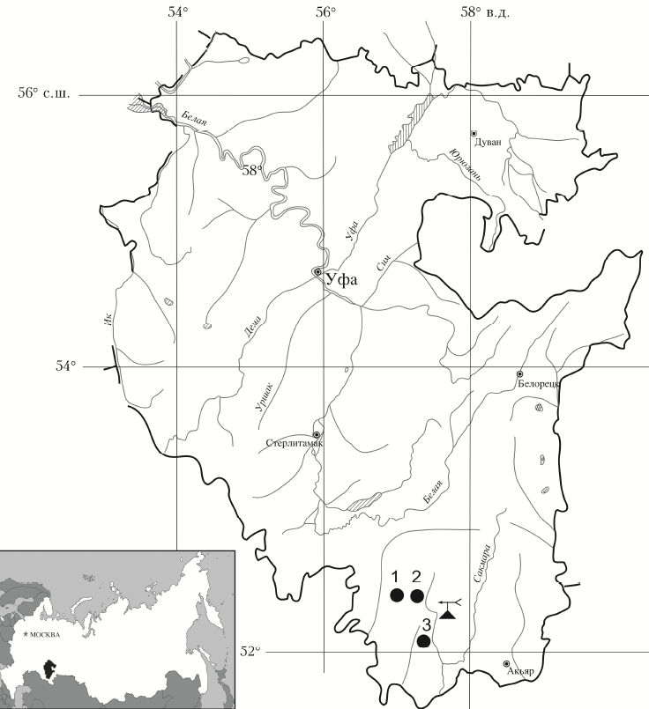

Picture 1. Map of Points …

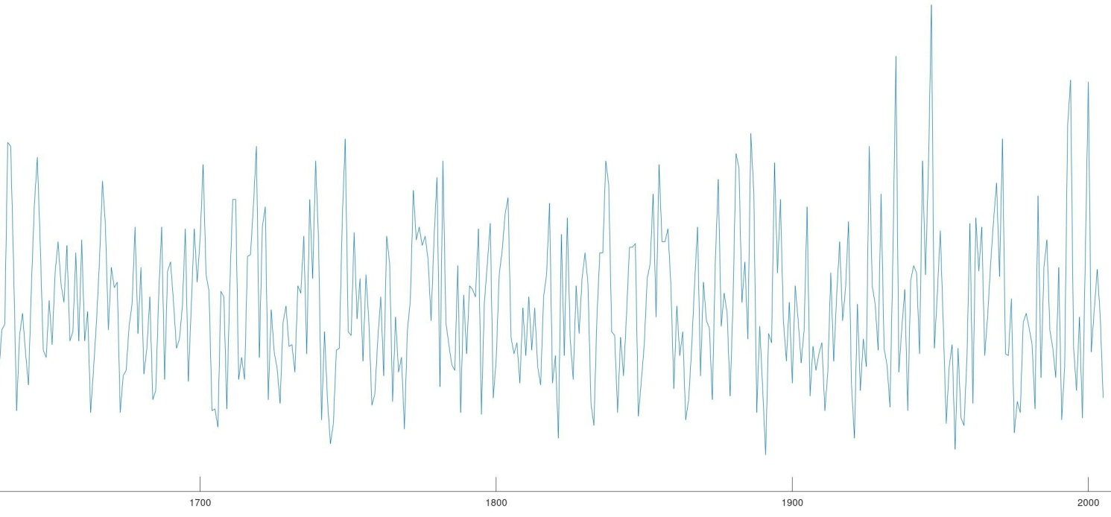

Picture 2. Graph of Larix 1631 - 2005

Picture 4. Graph of SMF 1631 – 2005